|  |  |  |  |  |  |
| --- | --- | --- | --- | --- | --- |
| Date | 29-Nov-22 | | | Tester Name | Andrew McLaughlin |
| Environment | Penfax - Test | | | Login used |  |
| Operating System | Windows | Version: | Update: | | |
| Software Used | Edge | Version: | Update: | | |
| Not Applicable | Version: | Update: | | |
| Release version | 22.4.1 | | | | |
| Title | M39.04 Death Joint Pensioner Calculates Onetime payment for death payout | | | | |
| Test Type | Regression | | | | |
| Test Scenario | M39.04 Death Joint Pensioner Calculates Onetime payment for death payout | | | | |
|  |  | | | | |
| Expected Results | When a pensioner dies with their estate as the beneficiary, their remaining payments should be paid out in a lump sum.   * We should be able to produce a one-time payment equal to their income benefit * periods remaining in guarantee period. | | | | |
| Pass/Fail | Fail | | | JIRA# | N/A |

Member is a widow and joint annuitant

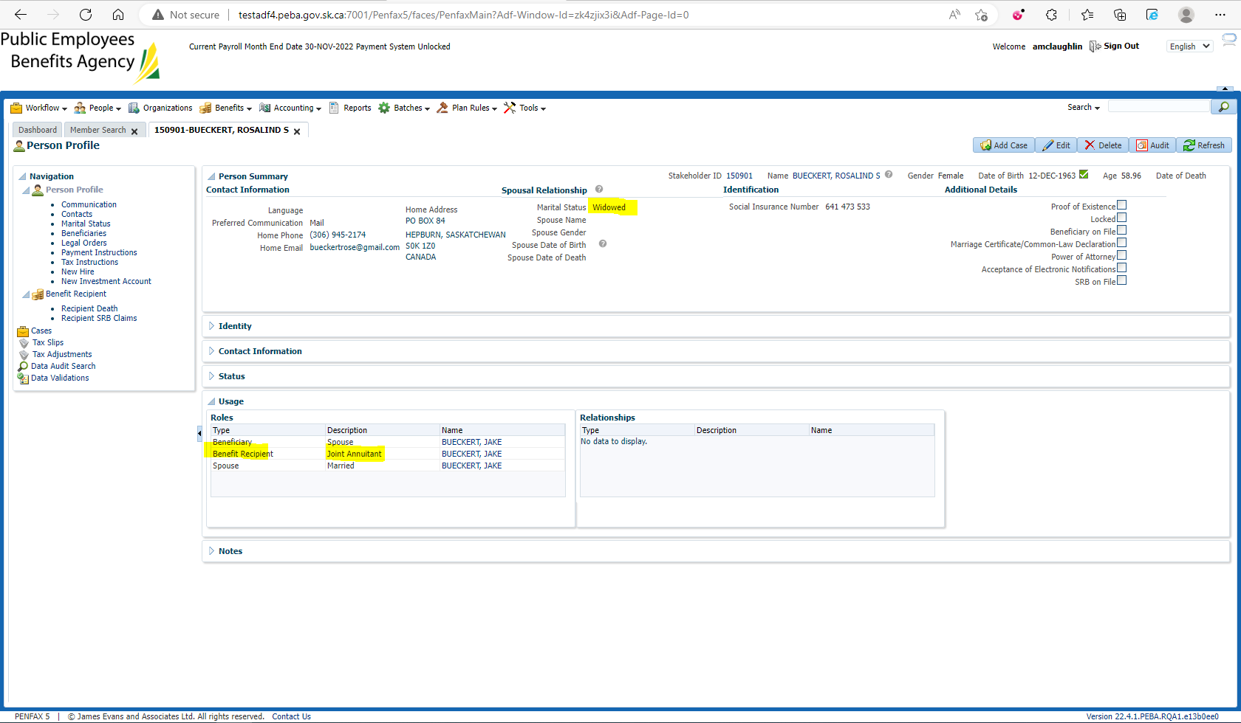

Member has their estate as their beneficiary: 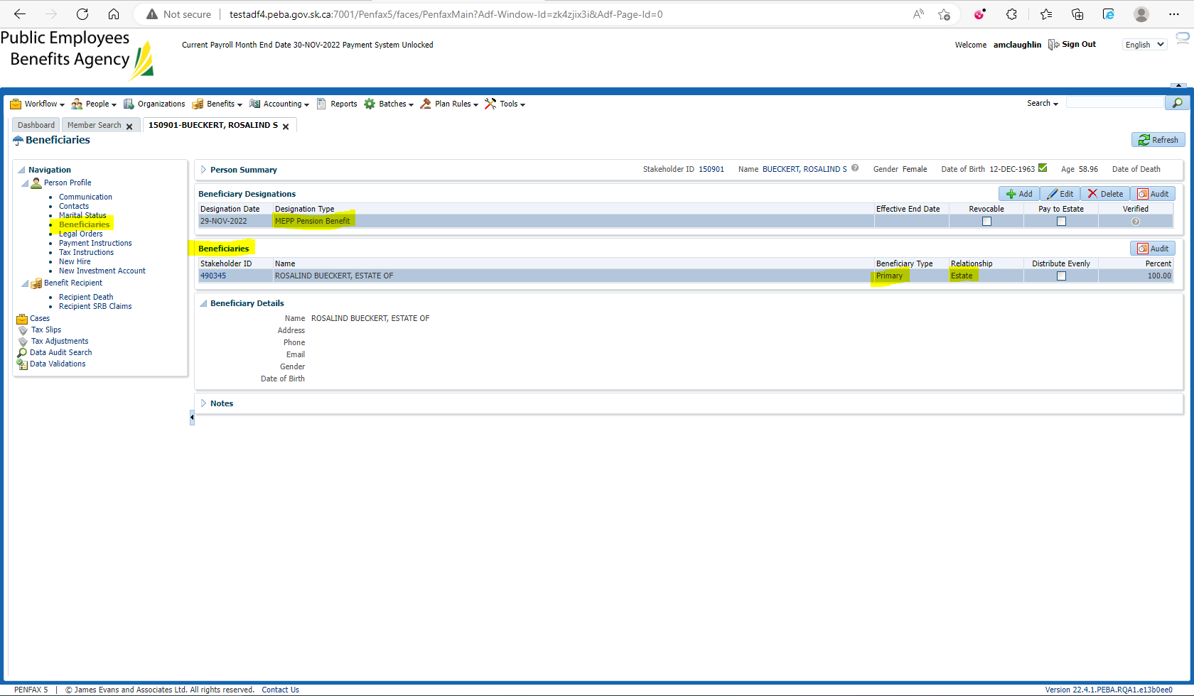

Pension amount is $652.91 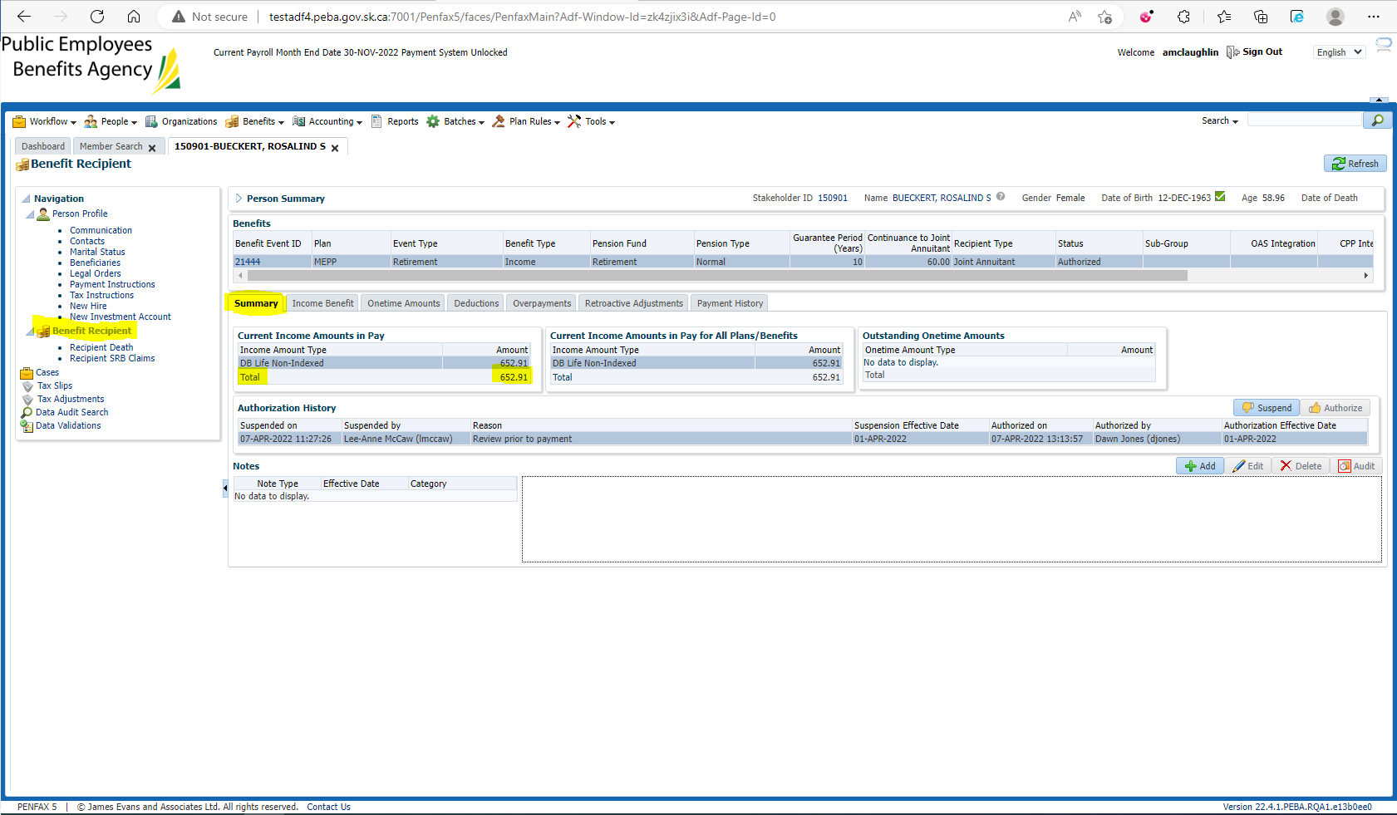

Enter Death Date:

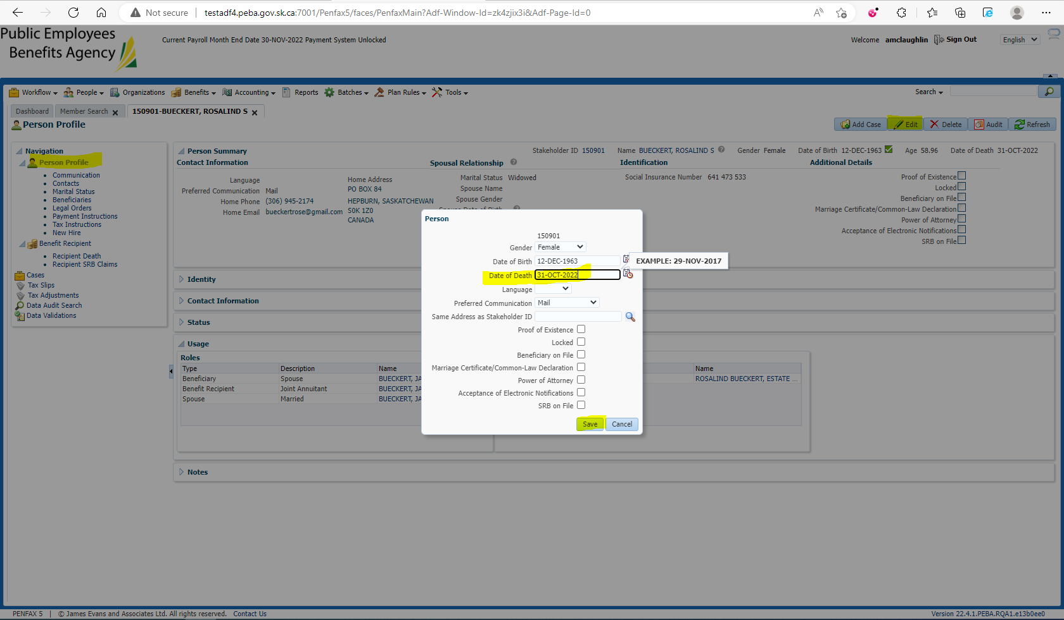

Verify the Retirement/Event Date and Survivor Start Date in the Member’s Benefit Event – 01-DEC-2019 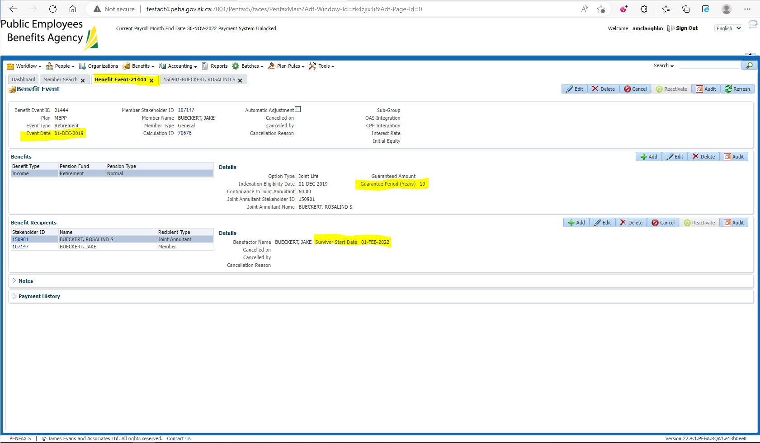

Open the Death Calc 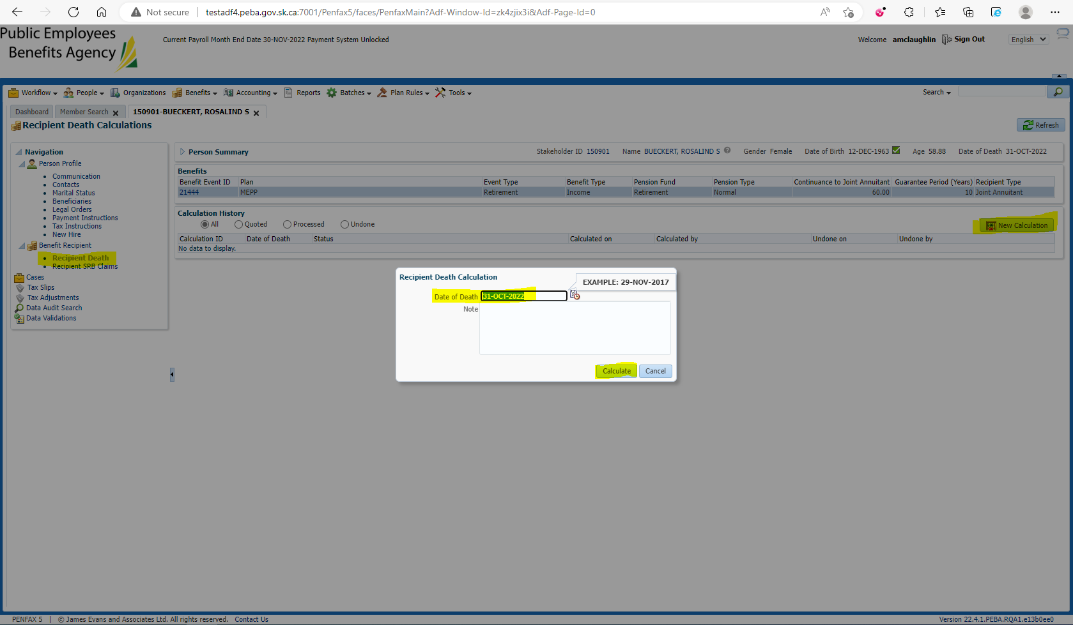

Verify the Lump Sum has been calculated correctly, Check the Pay as Lump Sum Box, Process, and Process Recipient

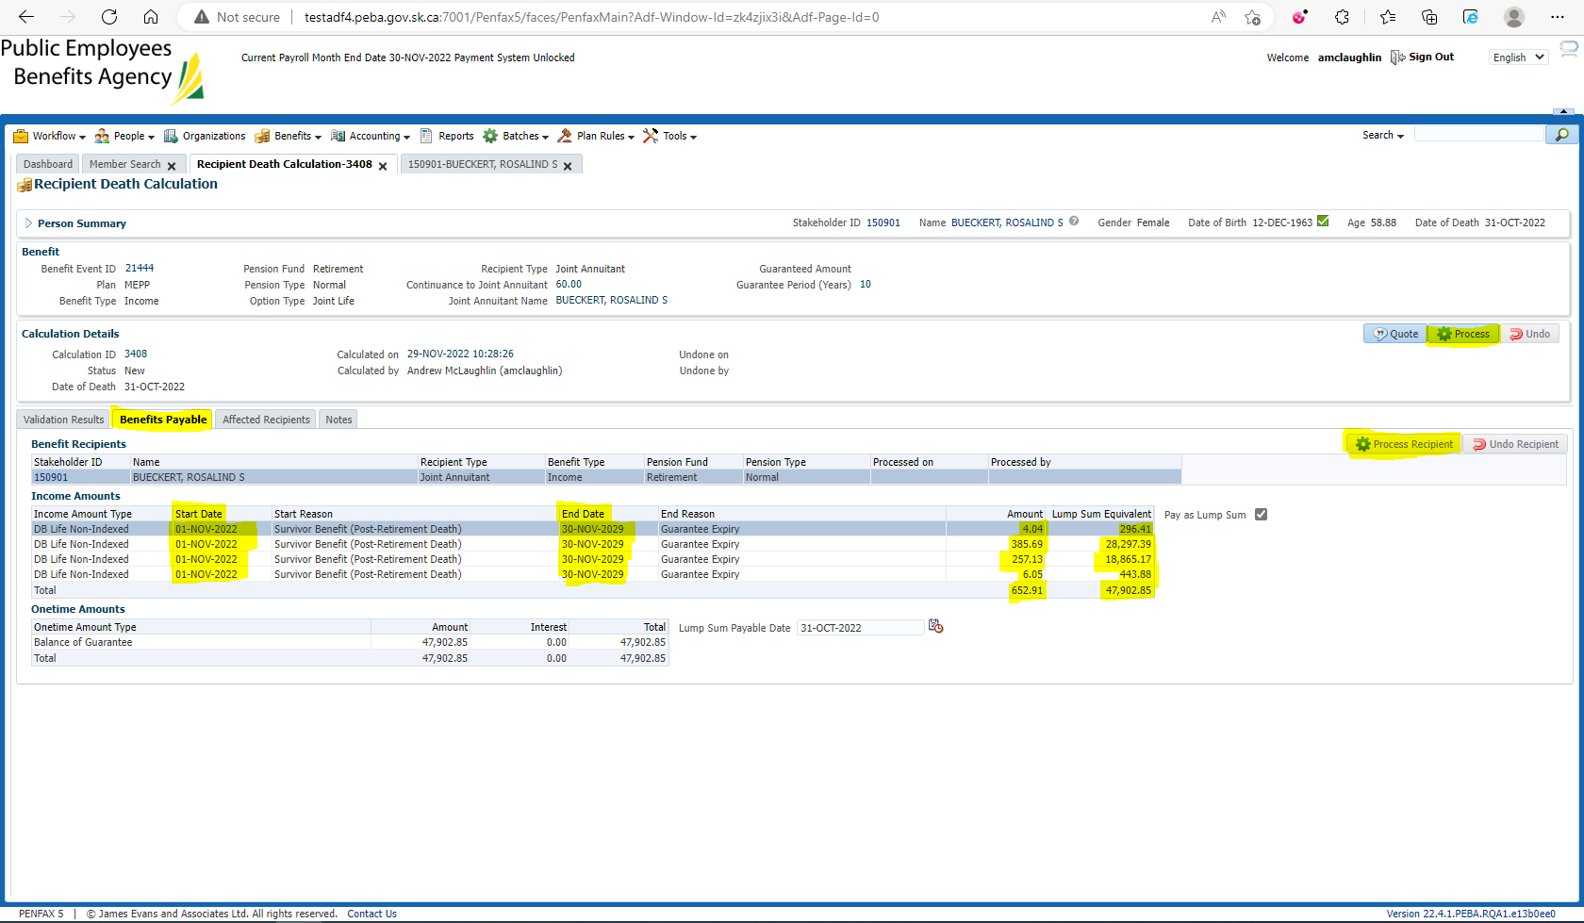

$47,902.85 matches production calculation

BUT

The calculation* should be (**months remaining in guarantee period) * (monthly payment)**

*In reality there may be actuarial adjustments to be made, but they would only increase the payment, not decrease it

85 months of payments remain (Nov 2022 – Nov 2029)

$4.04 * 85 = $343.40

$385.69 * 85 = $32,783.65

$257.13 * 85 = $21,856.05

$6.05 * 85 = $514.25

$652.91 * 85 = $55,497.35

Verify under the member’s Benefit Recipient that Lump Sum amount carries over: 